Assignment 10 Reflection:

All of the requirements for Assignment 10 are complete.

Although it took a little more time to figure out and get use to the recursive algorithms, the overall assignment wasn’t that bad. I was able to complete everything without any struggle.

**Survey:**

1. **Did you have knowledge about “recursion” before the class we just had?**
   1. Aside from reading about it in the book, no.
2. **Now, use your own language to describe what a recursion is.**
   1. Recursion is the act of taking a big problem and breaking it into smaller versions of itself. When it is possible to get smaller versions of a problem, recursion helps solve the problems with less code.
3. **In your experience, what were the difficulties of using recursion to solve problems?**
   1. My biggest difficulty was trying to figure out the algorithms for solving the various problems. Once I had an idea as to how the algorithm would work, it was pretty straightforward.
4. **Conceptually, is there still something about recursion you don’t understand or are confused about?**
   1. I still have some difficulty figuring out some algorithms for recursion but I do understand the basis of how recursion works.

**Recursion.java (Problems 1-4)**

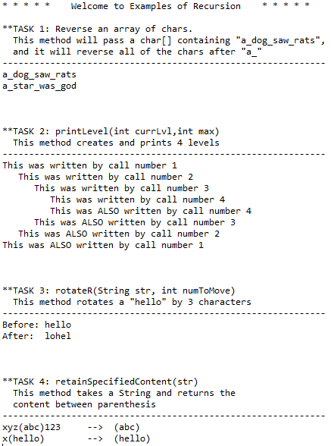

**Test Scenarios:**

The testing for problems 1-4 was pretty simple:

* Task 1: reverseArray(char[] arr, int lower, int upper)
  + If working properly, a char[] array should be returned in reversed order.
  + One thing to check was the pass of an empty array
    - The result returned nothing, as expected
* Task 2: printLevel(int currLvl, int max)
  + A precondition: currLvl can’t be greater than or equal to max
    - If this happens, the method returns without doing anything
      * However currLvl == max is also used to indicate whether or not the base case has been reached
* Task 3: rotateR(String str, int numToMove)
  + Output can be checked to determine if working properly.
    - Hello,3
      * Output is lohel
* Task 4: retainSpecifiedContent(String str)
  + If working properly, the content within and including the parenthesis will be returned
  + If the original string parameter being passed in doesn’t have parenthesis, the original word will be returned in parenthesis… something that could be changed depending on the requirements.